Name: Muhammad Imran Butt
Reg no: L1F24BSCS0546
Course: Information Security Lab
Section: E5

Lab 5

Experiment 1:

1. Generating Hashes

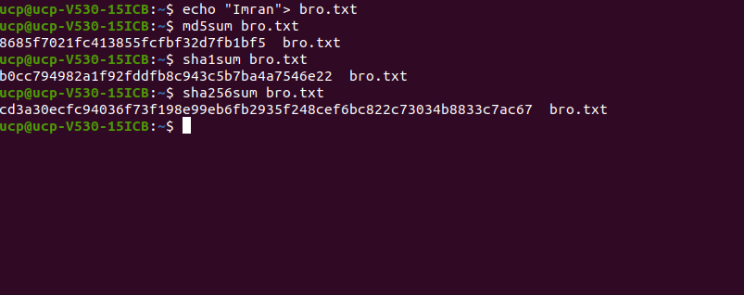
2. Compare digest lengths, avalanche effect, and collision resistance

Digest lengths:

md5sum: 128-bits

sha1sum: 160-bits
sha256sum: 256sum

Avalanche Effect:

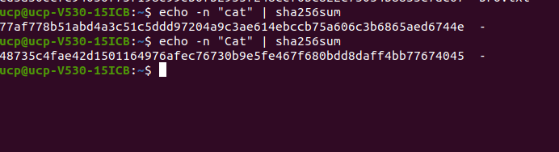

Collision Resistance:

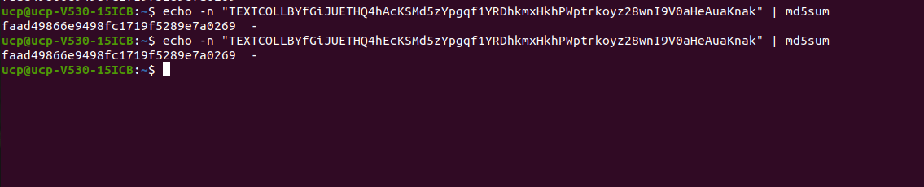

Experiment 2: Creating Salted Hashes

Generating hashes using algorithms 1, 5, and 6.

Experiment 3: Cracking MD5 Hash Using John the Ripper

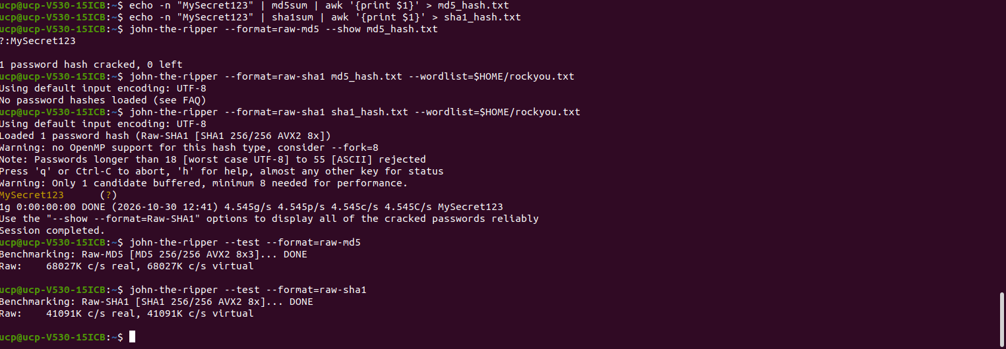

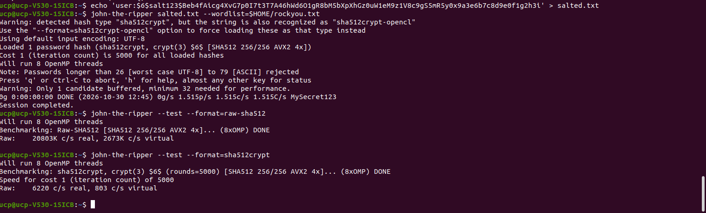
Experiment 4: Cracking a Salted SHA-512 Hash Using John

Experiment 5: Using Hashcat for GPU-Based Crackin

